**Big Mountain Resort Ticket Price Study Report**

The past few years have been rough for various companies within the entertainment and tourism sector as we all know. With increasing inflation coupled with the pandemic, many companies have seen harder times now than what could ever be expected just a few years ago. These problems were made further painful for our client, Big Mountain Resort, as previous to these past few years of turmoil they had made large investments to the resort's features, chiefly among them a new chair lift that was expected to increase operational costs for the park by at least 1.54 million dollars per season. The way that the park has currently been dealing with this problem is by charging a premium over the average ticket price for the area, but this strategy has not been working out for them. How then should we change ticket prices and amenities to not only account for these changes but also come out of this ordeal with the maximum possible profits, making up for previous losses and solidifying a more secure future for Big Mountain Resort? This report serves to answer these questions and explain the thought process behind the results given, so let’s dive in.

*Subsection 1: Immediate Ticket Price Changing*

As previously stated, the park is struggling with operations at the current value of ticketing. This is due to, as I see it, a flaw in the perceived value of the park and its given amenities. The current value of tickets is determined by taking a premium of the average price of other resorts in its market segment. This can work okay as a model, but it fails to recognize the variety of reasons a person may choose one resort over another and ignores that Big Mountain is top in its field in many amenities from a country-wide perspective. Additionally it was determined that state location had much less to do with the outcomes of parks within the given state, as there seemed to be little to no pattern between the average prices of the given states, as seen in figure 1. Saying that, the decision was made to model the problem by including all states together. Then, what other systems could be used to determine the best ticket pricing strategy for the company? Because looking at state averages was shown to be less than effective, the decision was made to look at this problem from the standpoint of what amenities were the most attractive to potential customers, and to determine what factors are more and less important a few different models were tested out. The one that was eventually chosen was a random forest model, as it showed the most accuracy and the least mean absolute error. Using this model, the importance of the various features was able to be determined as seen in figure 2. As you can see, the features that were seen as being the most important were the amount of fast quads, the total number of runs, the total amount of snow making done in the park, and finally the vertical drop. That is not to say the other factors were not of any importance, but the model deemed these to be the most important features in what supports a higher ticket price. This model, which shows much higher fidelity than what is the currency used, ended up showing that Big Mountain Resort could charge $95.87 for the tickets, and even accounting for the mean absolute error of $10.39 it would still allow for a ticket price of $85.48, over 4 dollars what is currently charged ($81). It is because of this that I would suggest the resort make an immediate price increase of at least $4.50 (new ticket price of $85.50), as that would theoretically increase yearly park revenue by approximately $7.875 million per year without needing to make any further adjustments to the park.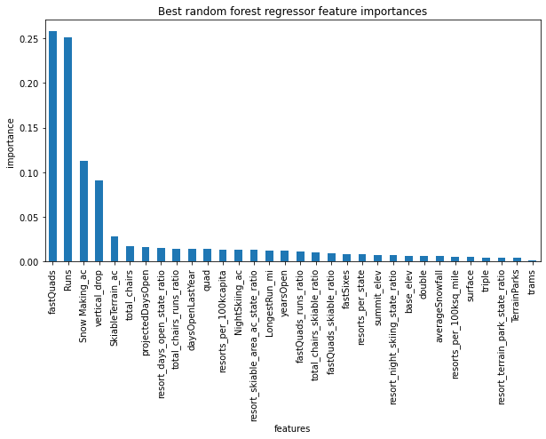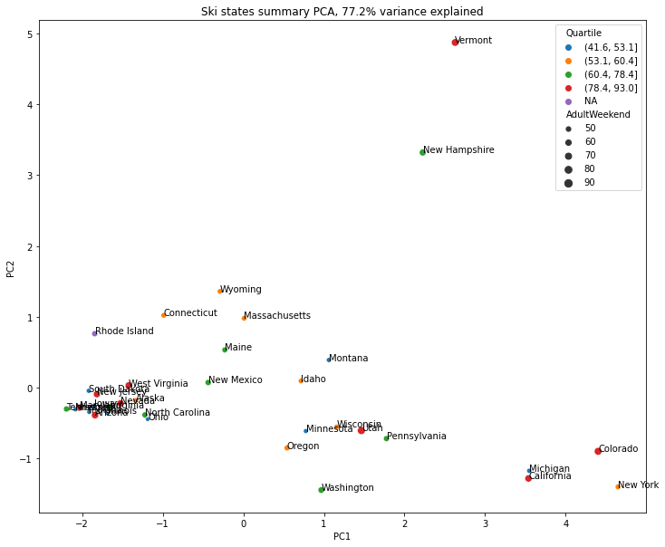

*Subsection 2: Park Modification Scenearios*

Additionally, when approached by Big Mountian Resort, I recieved a short list of additional changes that could be made in order to either cut costs or increase the value in such a way that it would increase profits for the company. They were as follows:

* Permanently closing down up to 10 of the least used runs. This doesn't impact any other resort statistics.
* Increase the vertical drop by adding a run to a point 150 feet lower down but requiring the installation of an additional chair lift to bring skiers back up, without additional snow making coverage
* Same as number 2, but adding 2 acres of snow making cover
* Increase the longest run by 0.2 mile to boast 3.5 miles length, requiring an additional snow making coverage of 4 acres

The first proposal of shutting down the least used runs would be a good place to start, as there is quite a bit of nuance to that proposal. In the model, despite the total runs being important to the ticket price as seen in figure 2, it still seems that the least used run could be shut down without any fluctuations to the perceived ticket price. Further information on additional price changes can be found in figure 3, but it is fair to say that the option that is most generally positive is the scenario of shutting down only one run as it seems to have no effect while also lowering operation costs, and as the cost of operating runs was not given this will be the suggestion for the first given scenario. For the other scenarios it was just a matter of determining how adding to the parks existing infrastructure would make for better yearly revenue. What the modeling for the second proposition showed was that the revenue of such a project would increase yearly revenue by approximately $15.065 million, and considering the expected cost of operation of the previous lift being at around $1.54 million, this would be a great new addition the the park. With the third scenario being a modification to the second accounting for snow making in the area, it was expected to increase revenue by around $17.323 million, this could be an even better development, but as no concrete numbers on the yearly cost of snow making were given I am less likely to suggest this scenario as it could be somewhat less profitable. In the fourth and final scenario, the model predicted that there would be no increase to the value of the ticket in making the change. This is probably because the model that was used placed very little importance on the length of the longest run (see figure 2). Because of this, I feel fairly comfortable in not suggesting the fourth option to Big Mountain Resort as it would just incur more cost from the additional snow making and seemingly has no benefit. 